Week 2 : Visualisation

Assignment Submission

Recreate the R code necessary to generate the following graphs:

1. Using mpg data frame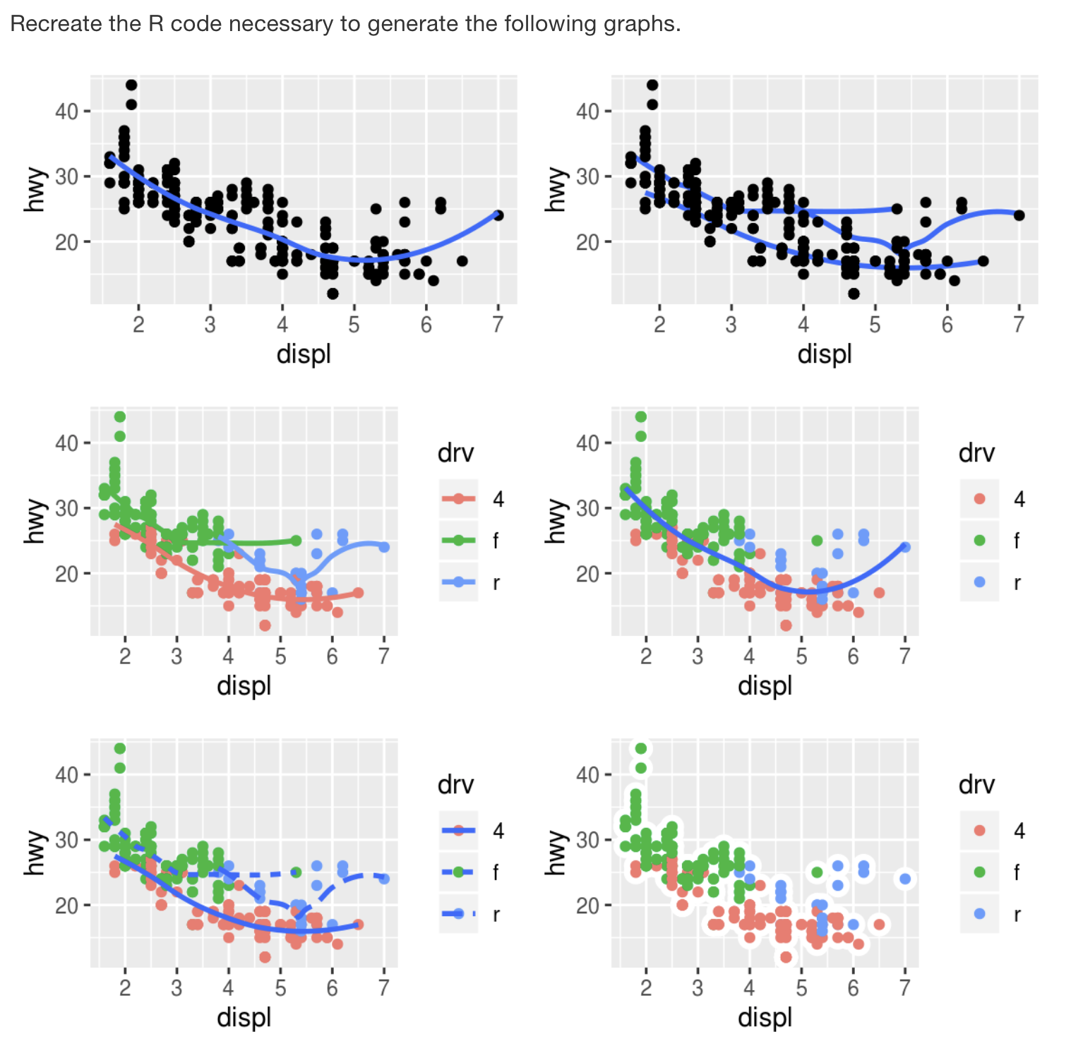
2. Using diamonds data frame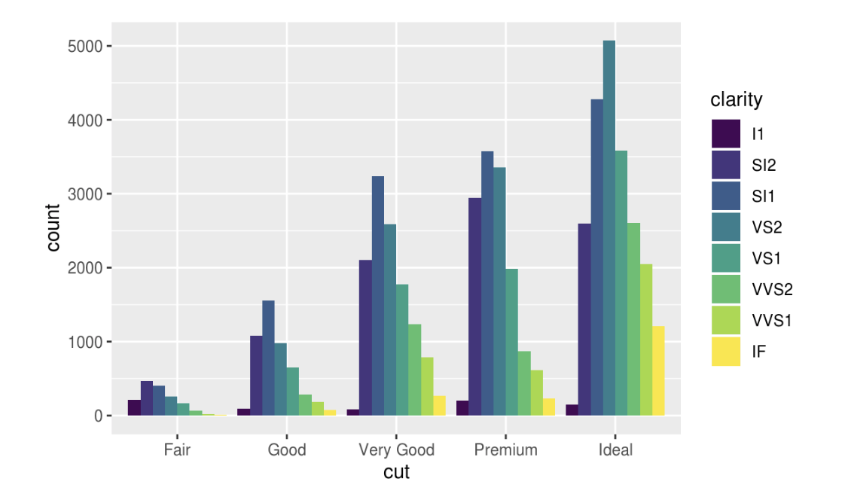

**ANSWERS**

**Question N0-1**

**01-**

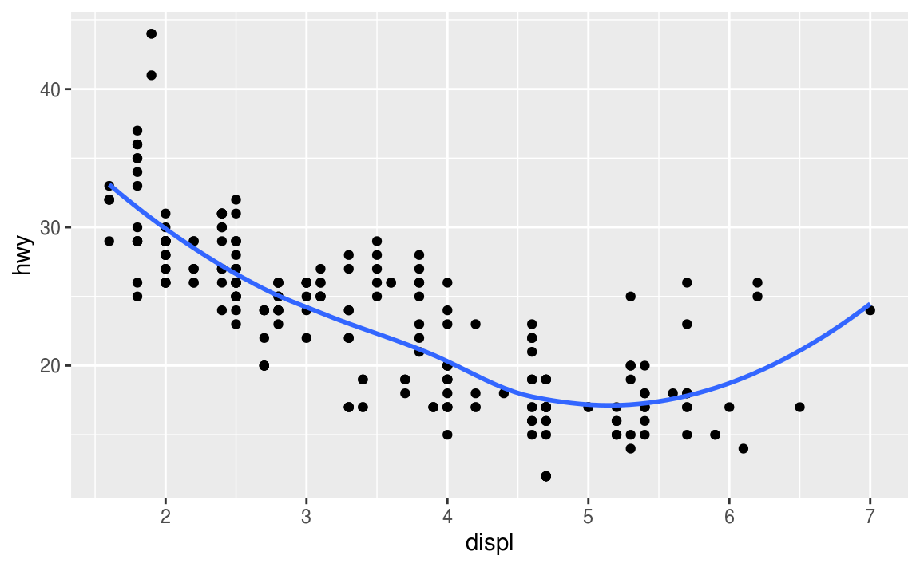

ggplot(mpg, aes(x = displ, y = hwy)) +

geom_point() +

geom_smooth(se = FALSE)

**02-**

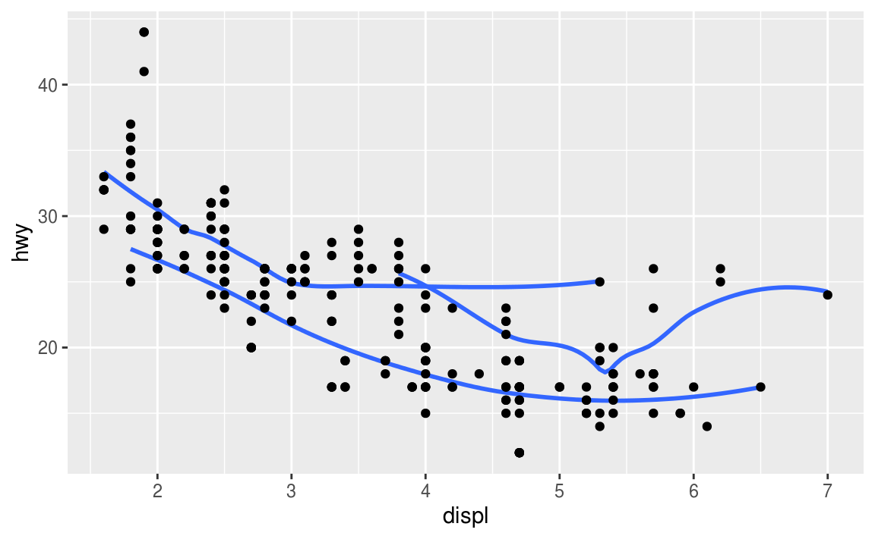

ggplot(mpg, aes(x = displ, y = hwy)) +

geom_smooth(mapping = aes(group = drv), se = FALSE) +

geom_point()

**03-**

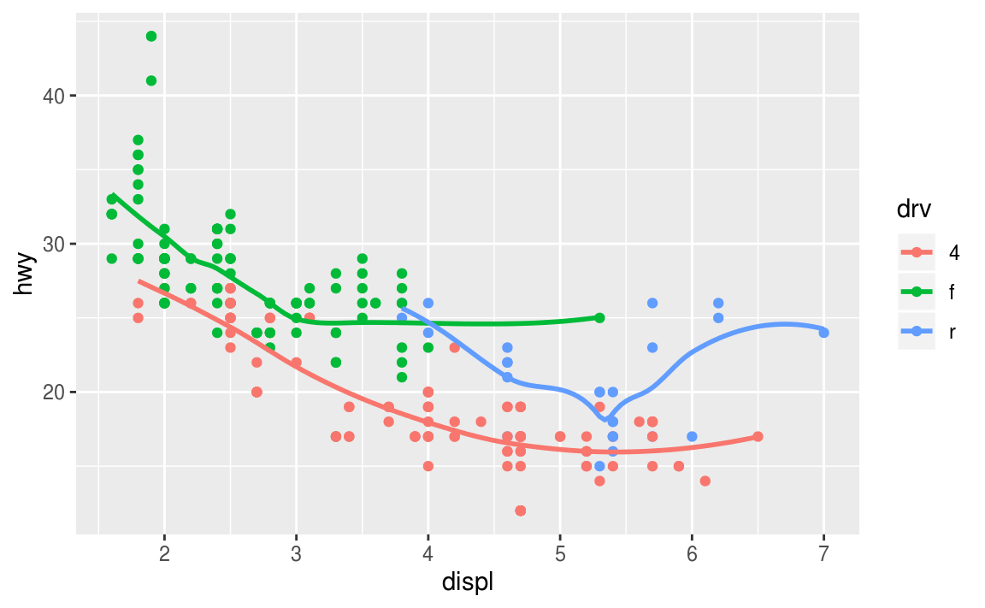

ggplot(mpg, aes(x = displ, y = hwy, colour = drv)) +

geom_point() +

geom_smooth(se = FALSE)

**04-**

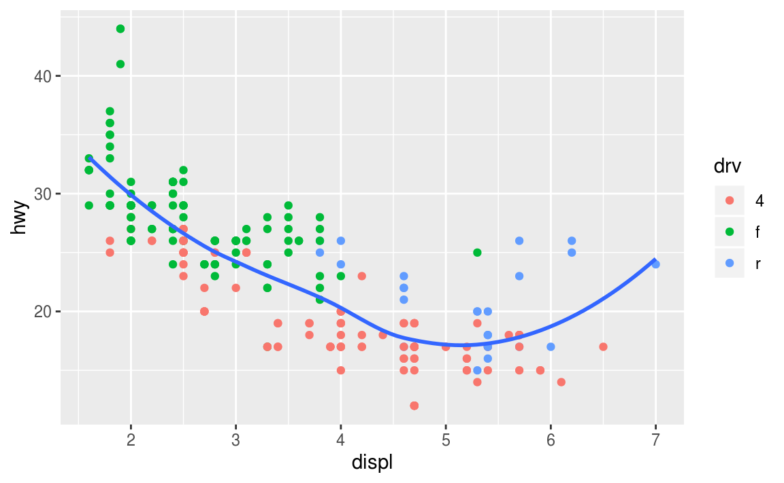

ggplot(mpg, aes(x = displ, y = hwy)) +

geom_point(aes(colour = drv)) +

geom_smooth(se = FALSE)

**05-**

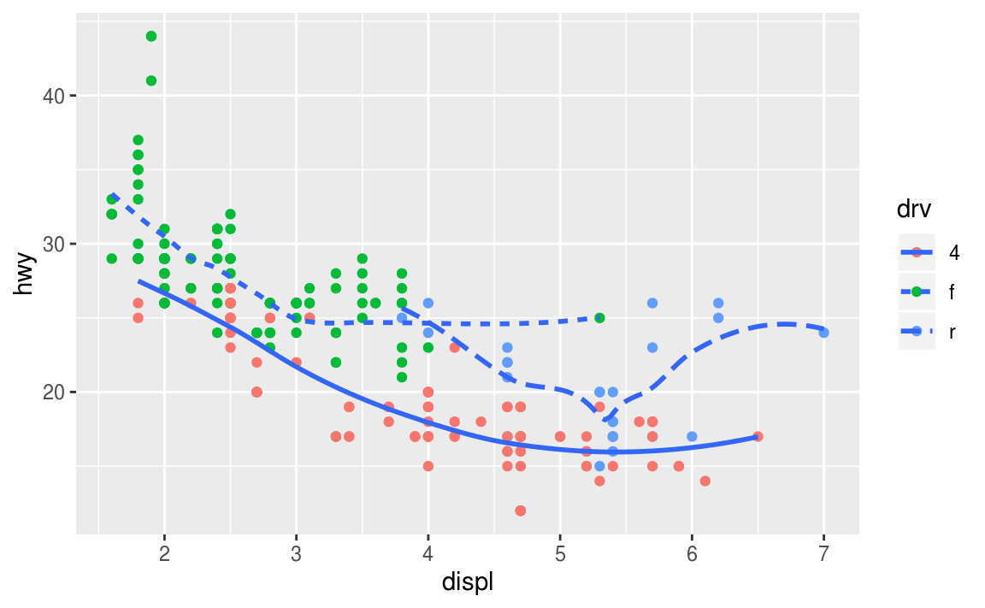

ggplot(mpg, aes(x = displ, y = hwy)) +

geom_point(aes(colour = drv)) +

geom_smooth(aes(linetype = drv), se = FALSE)

#> `geom_smooth()` using method = 'loess' and formula 'y ~ x'

**06-**

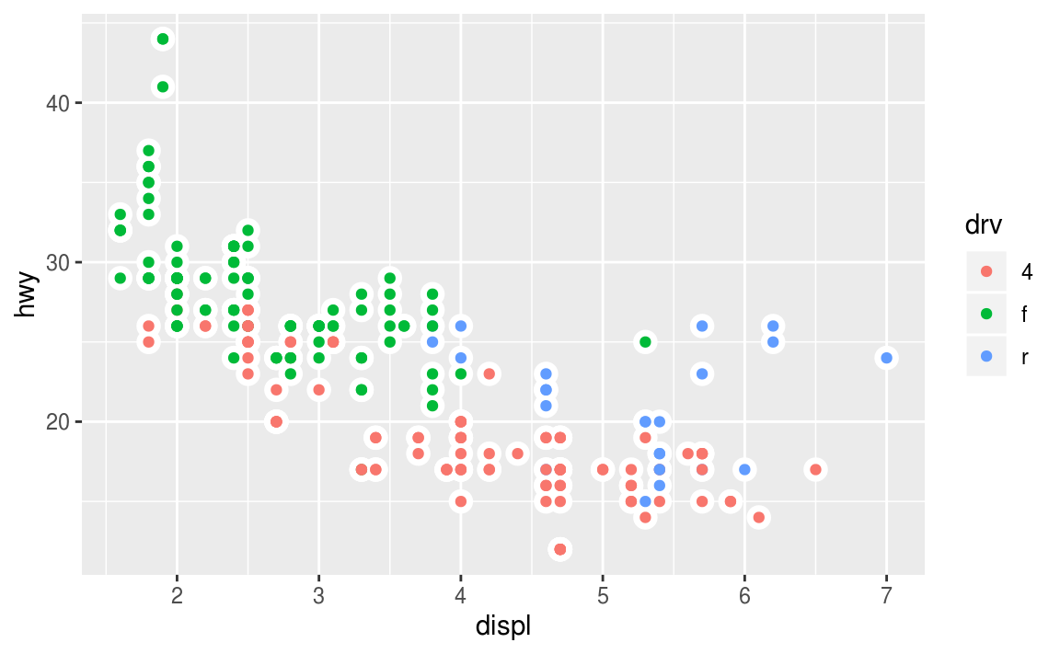

ggplot(mpg, aes(x = displ, y = hwy)) +

geom_point(size = 4, color = "white") +

geom_point(aes(colour = drv))

**Question N0-2**



ggplot(data = diamonds) +

geom_bar(

mapping = aes(x = cut, fill = clarity),

position = "dodge"

)